Task 1

All environment of py is ready to use

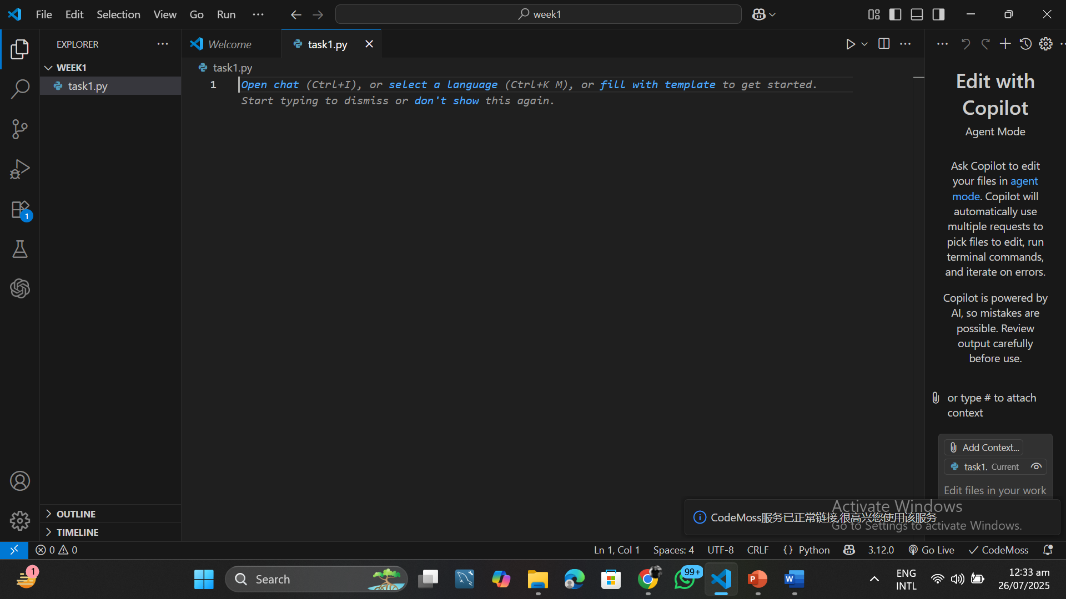

Task 2

Print is use to dispaly a message

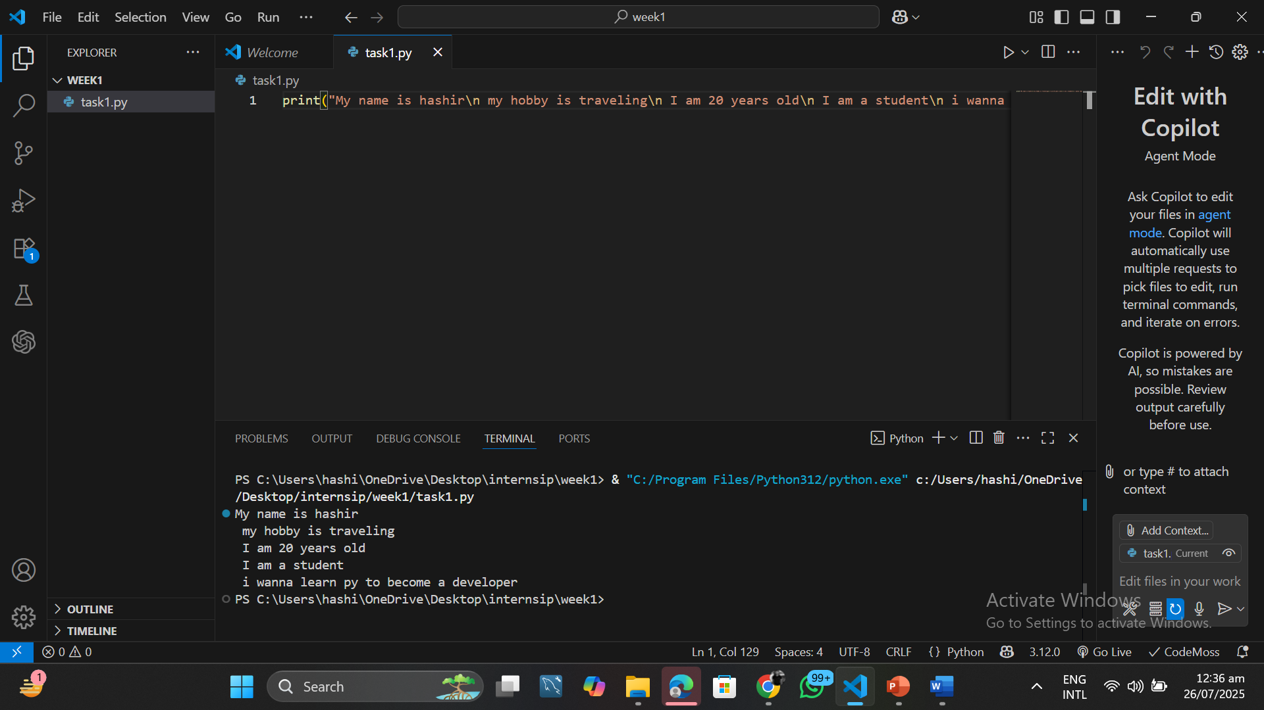

Task 3

Adding two numbers using input first, we create two variables and then sum those two variables and display it using print

